Code:

index.html
<!DOCTYPE html>
<html lang="en">
<head>
<meta charset="UTF-8" />
<meta name="viewport" content="width=device-width, initial-scale=1.0"/>
<title>Experiment 7 - AJAX Form Validation</title>
<link rel="stylesheet" href="styles.css" />
</head>
<body>
<main class="container">
<h1>Experiment 7: AJAX Form Validation</h1>
<p>Real-time validation using AJAX without page reload.</p>
<form id="myForm">
<input type="text" id="username1" placeholder="Username"
onblur="validate('username', this.value)">
<div id="username"></div>

<input type="password" id="password1" placeholder="Password"
onblur="validate('password', this.value)">
<div id="password"></div>
<input type="text" id="email1" placeholder="Email"
onblur="validate('email', this.value)">
<div id="email"></div>
<button type="button" onclick="checkForm()">Submit</button>
</form>
<pre id="output"></pre>
<p>Devang Deokule - A58</p>
</main>
<script src="script.js"></script>
</body>
</html>

styles.css

body {
margin: 0;
font-family: "Segoe UI", Tahoma, Geneva, Verdana, sans-serif;
min-height: 100vh;
display: flex;
justify-content: center;
padding: 1.5rem 1rem;
background: #f8f8f8;
}
.container {
width: min(100%, 720px);
padding: 1.5rem;
border: 1px solid #d8d8d8;
background: #fff;
}
h1 {
max-width: 28ch;
margin: 0 auto 1rem;
text-align: center;
font-weight: 700;
line-height: 1.25;
}

input {
width: 100%;
margin-top: 0.6rem;
padding: 0.5rem;
border: 1px solid #ccc;
}
button {
margin-top: 1rem;
border: 1px solid #444;
background: #f0f0f0;
padding: 0.45rem 0.85rem;
cursor: pointer;
}
div {
font-size: 0.9rem;
color: red;
}
pre {
margin-top: 1rem;
border: 1px solid #ddd;
padding: 0.8rem;
background: #fafafa;
white-space: pre-wrap;
}

script.js

function validate(field, value) {
var xhr = new XMLHttpRequest();
xhr.onreadystatechange = function () {
if (xhr.readyState === 4 && xhr.status === 200) {
document.getElementById(field).innerHTML = xhr.responseText;
}
};
xhr.open("GET", "validation.php?field=" + field + "&query=" + value, true);
xhr.send();
}
function checkForm() {
var u = document.getElementById("username1").value;
var p = document.getElementById("password1").value;
var e = document.getElementById("email1").value;
if (u === "" || p === "" || e === "") {
alert("Fill All Fields");
return;
}
if (
document.getElementById("username").innerText.includes("Must") ||
document.getElementById("password").innerText.includes("short") ||
document.getElementById("email").innerText.includes("Invalid")
) {
alert("Fill Valid Information");
} else {
document.getElementById("output").innerText =
"Form submitted successfully";
}
}

validation.php

function validate(field, value) {
var xhr = new XMLHttpRequest();
xhr.onreadystatechange = function () {
if (xhr.readyState === 4 && xhr.status === 200) {
document.getElementById(field).innerHTML = xhr.responseText;
}
};
xhr.open("GET", "validation.php?field=" + field + "&query=" + value, true);
xhr.send();
}
function checkForm() {
var u = document.getElementById("username1").value;
var p = document.getElementById("password1").value;
var e = document.getElementById("email1").value;
if (u === "" || p === "" || e === "") {
alert("Fill All Fields");
return;
}
if (
document.getElementById("username").innerText.includes("Must") ||
document.getElementById("password").innerText.includes("short") ||
document.getElementById("email").innerText.includes("Invalid")
) {
alert("Fill Valid Information");
} else {
document.getElementById("output").innerText =
"Form submitted successfully";
}
}

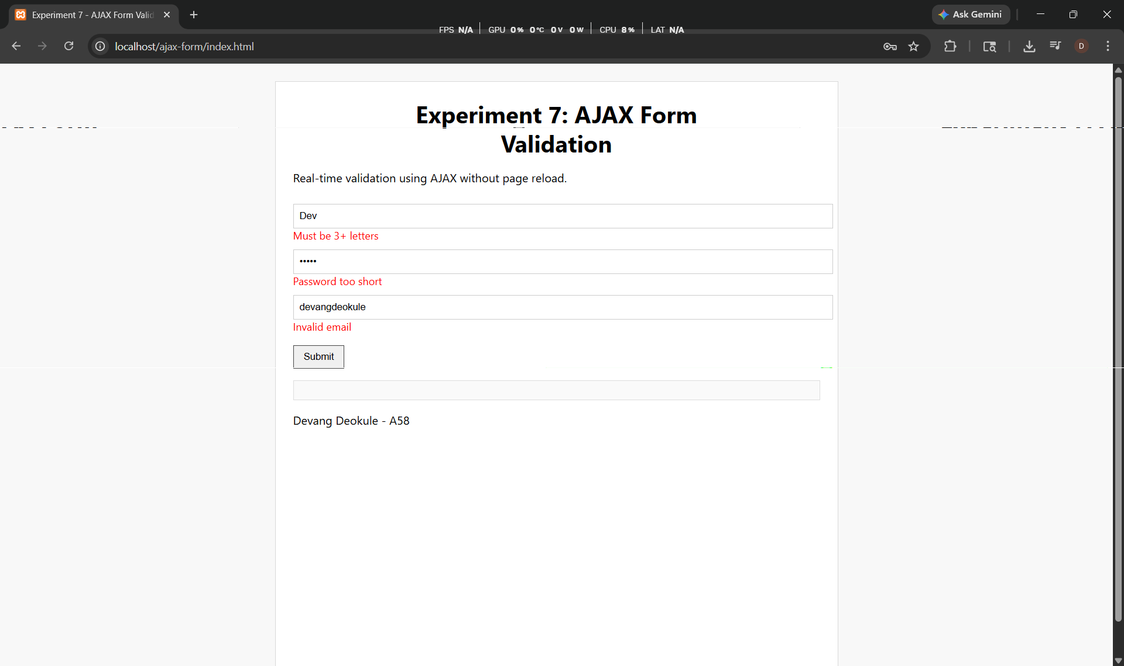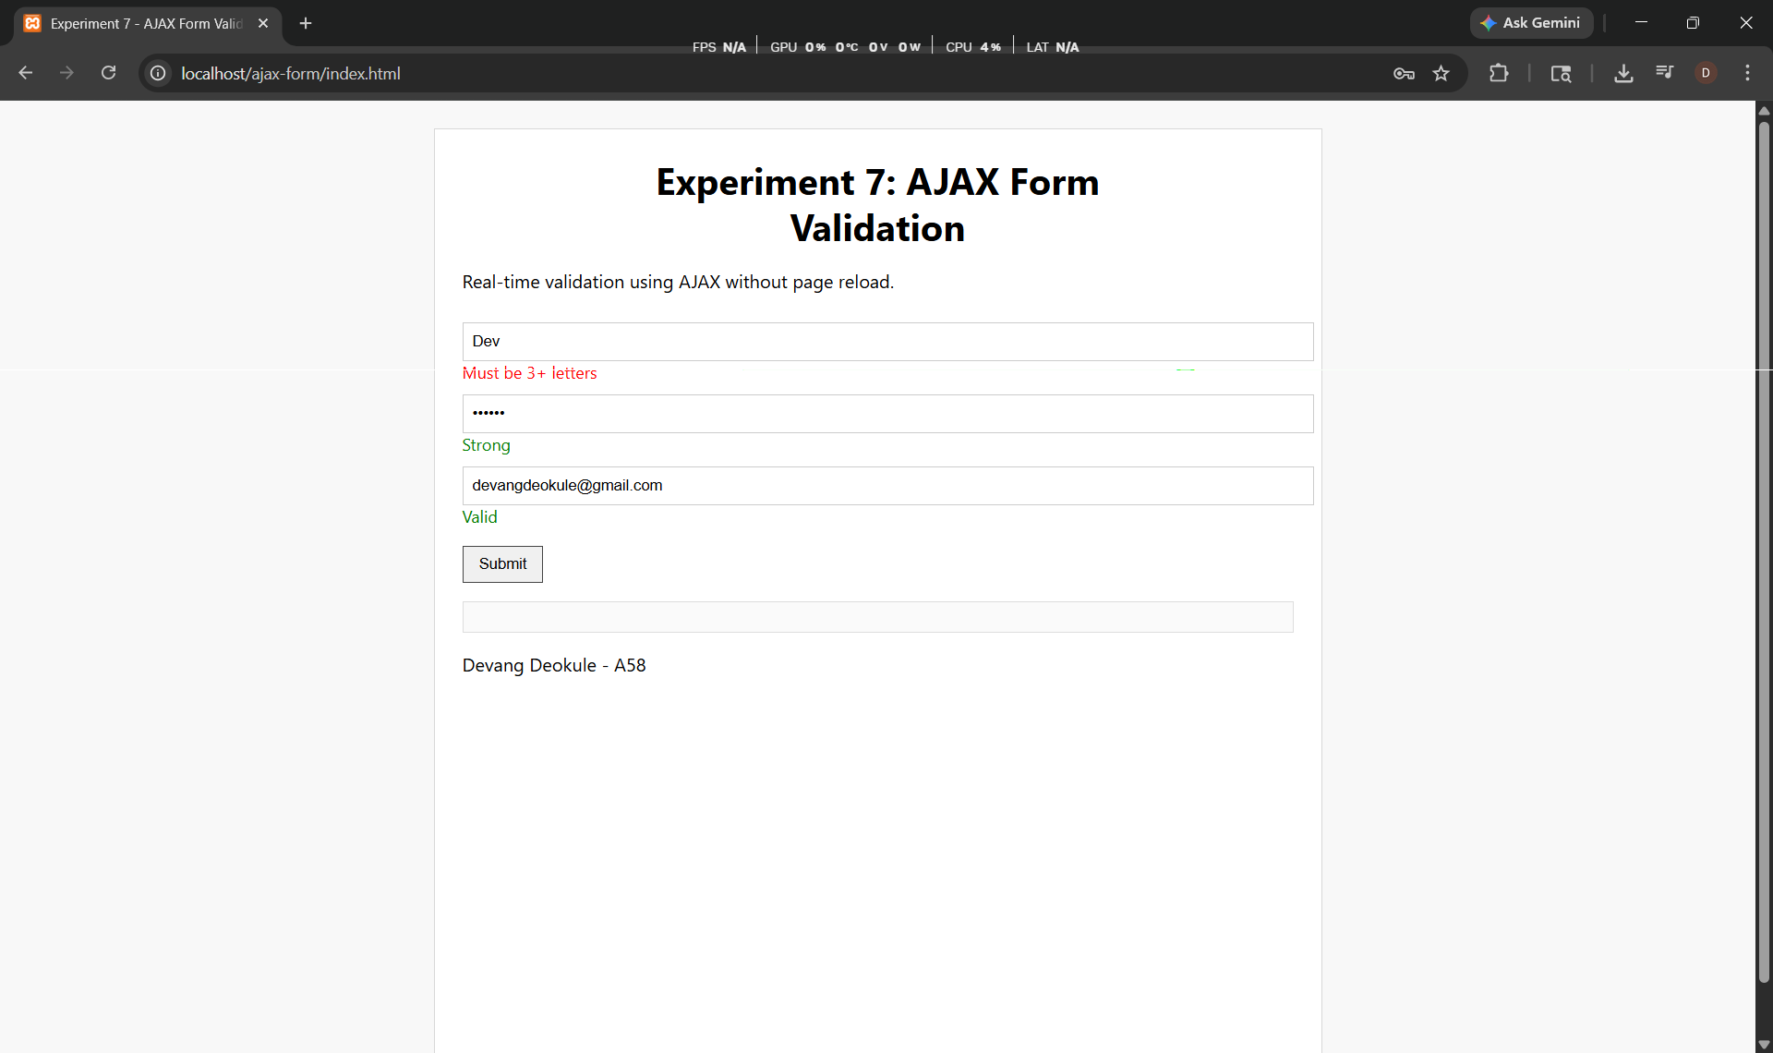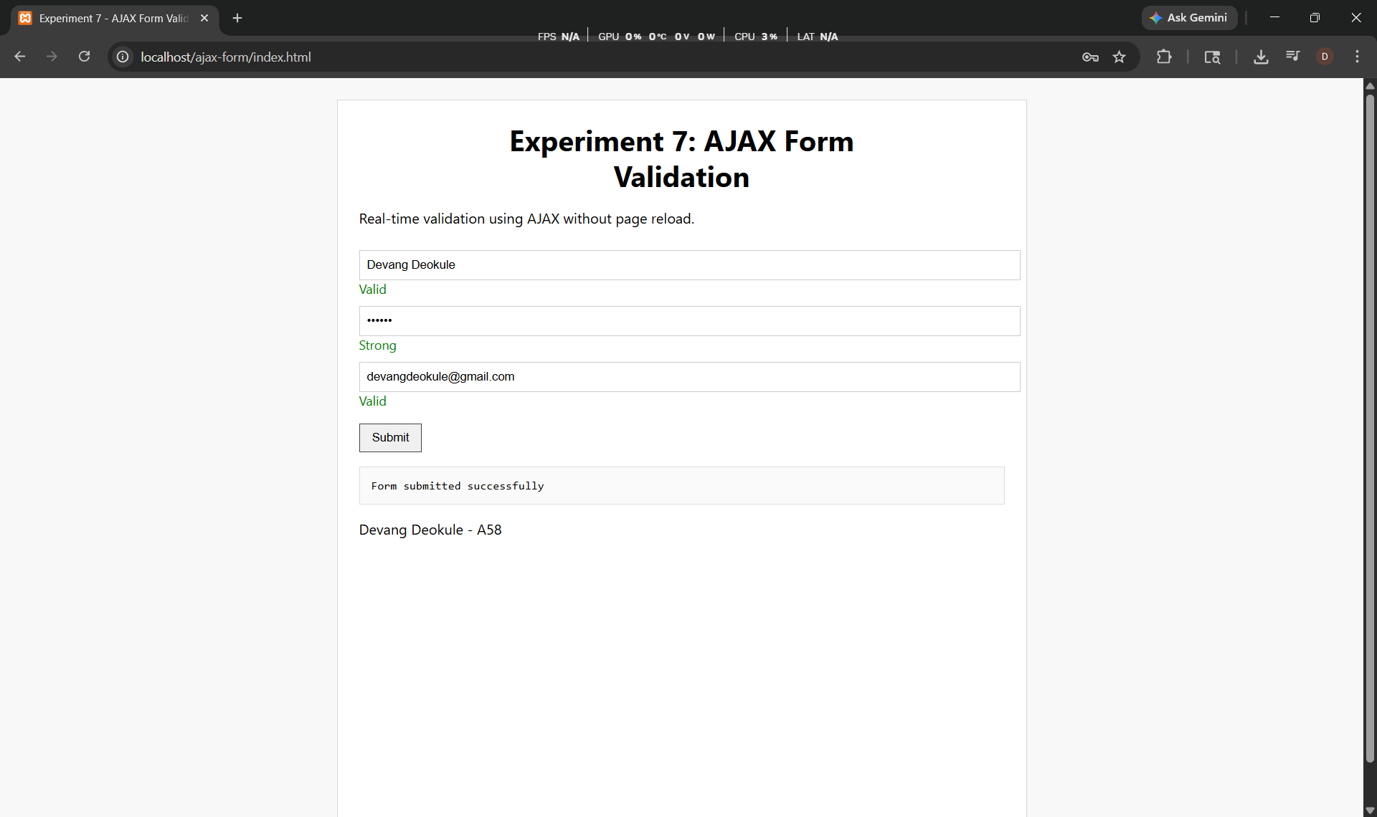
Code:
main.py
from flask import Flask, render_template, request
from forms import ContactForm
import pandas as pd

app = Flask(__name__)
app.secret_key = 'devang_secret'

@app.route('/contactus', methods=["GET", "POST"])

def get_contact():
form = ContactForm()

if request.method == 'POST':
name = request.form["name"]
email = request.form["email"]
subject = request.form["subject"]
message = request.form["message"]
res = pd.DataFrame({
'name': [name],
'email': [email],
'subject': [subject],
'message': [message]
})
res.to_csv('contactusMessage.csv', mode='a', index=False, header=False)
return render_template('contact.html', form=form)

if __name__ == '__main__':
app.run(debug=True)

forms.py
from flask_wtf import FlaskForm
from wtforms import StringField, TextAreaField, SubmitField

class ContactForm(FlaskForm):
name = StringField("Name")
email = StringField("Email")
subject = StringField("Subject")
message = TextAreaField("Message")
submit = SubmitField("Send")

templates/contact.html
<!DOCTYPE html>
<html>
<head>
<title>Experiment 9 - Flask Feedback Form</title>
<link rel="stylesheet" href="{{ url_for('static', filename='styles.css') }}">
</head>
<body>
<div class="container">
<h1>Experiment 9: Feedback Form using Flask</h1>
<p class="desc">
Aim: To design and implement a web-based feedback form using Flask framework.
</p>
<form method="POST">
{{ form.hidden_tag() }}
<input type="text" name="name" placeholder="Your name">
<input type="text" name="email" placeholder="Your email">
<input type="text" name="subject" placeholder="Subject">
<textarea name="message" placeholder="Message"></textarea>
<input type="submit" value="Send">
</form>
<p class="footer">Devang Deokule - A58</p>
</div>
</body>
</html>

static/syles.css

body {
margin: 0;
font-family: "Segoe UI", Tahoma, Geneva, Verdana, sans-serif;
min-height: 100vh;
display: flex;
justify-content: center;
padding: 1.5rem 1rem;
background: #f8f8f8;
}
.container {
width: min(100%, 500px);
padding: 1.5rem;
border: 1px solid #d8d8d8;
background: #fff;
}
h1 {
text-align: center;
margin-bottom: 10px;
}
.desc {
text-align: center;
color: #555;
margin-bottom: 20px;
}
input, textarea {
width: 100%;
margin-top: 10px;
padding: 10px;
border: 1px solid #ccc;
}

textarea {
height: 100px;
}
input[type="submit"] {
margin-top: 15px;
background: #2a78ca;
color: white;
border: none;
cursor: pointer;
}
.footer {
margin-top: 15px;
text-align: center;
}

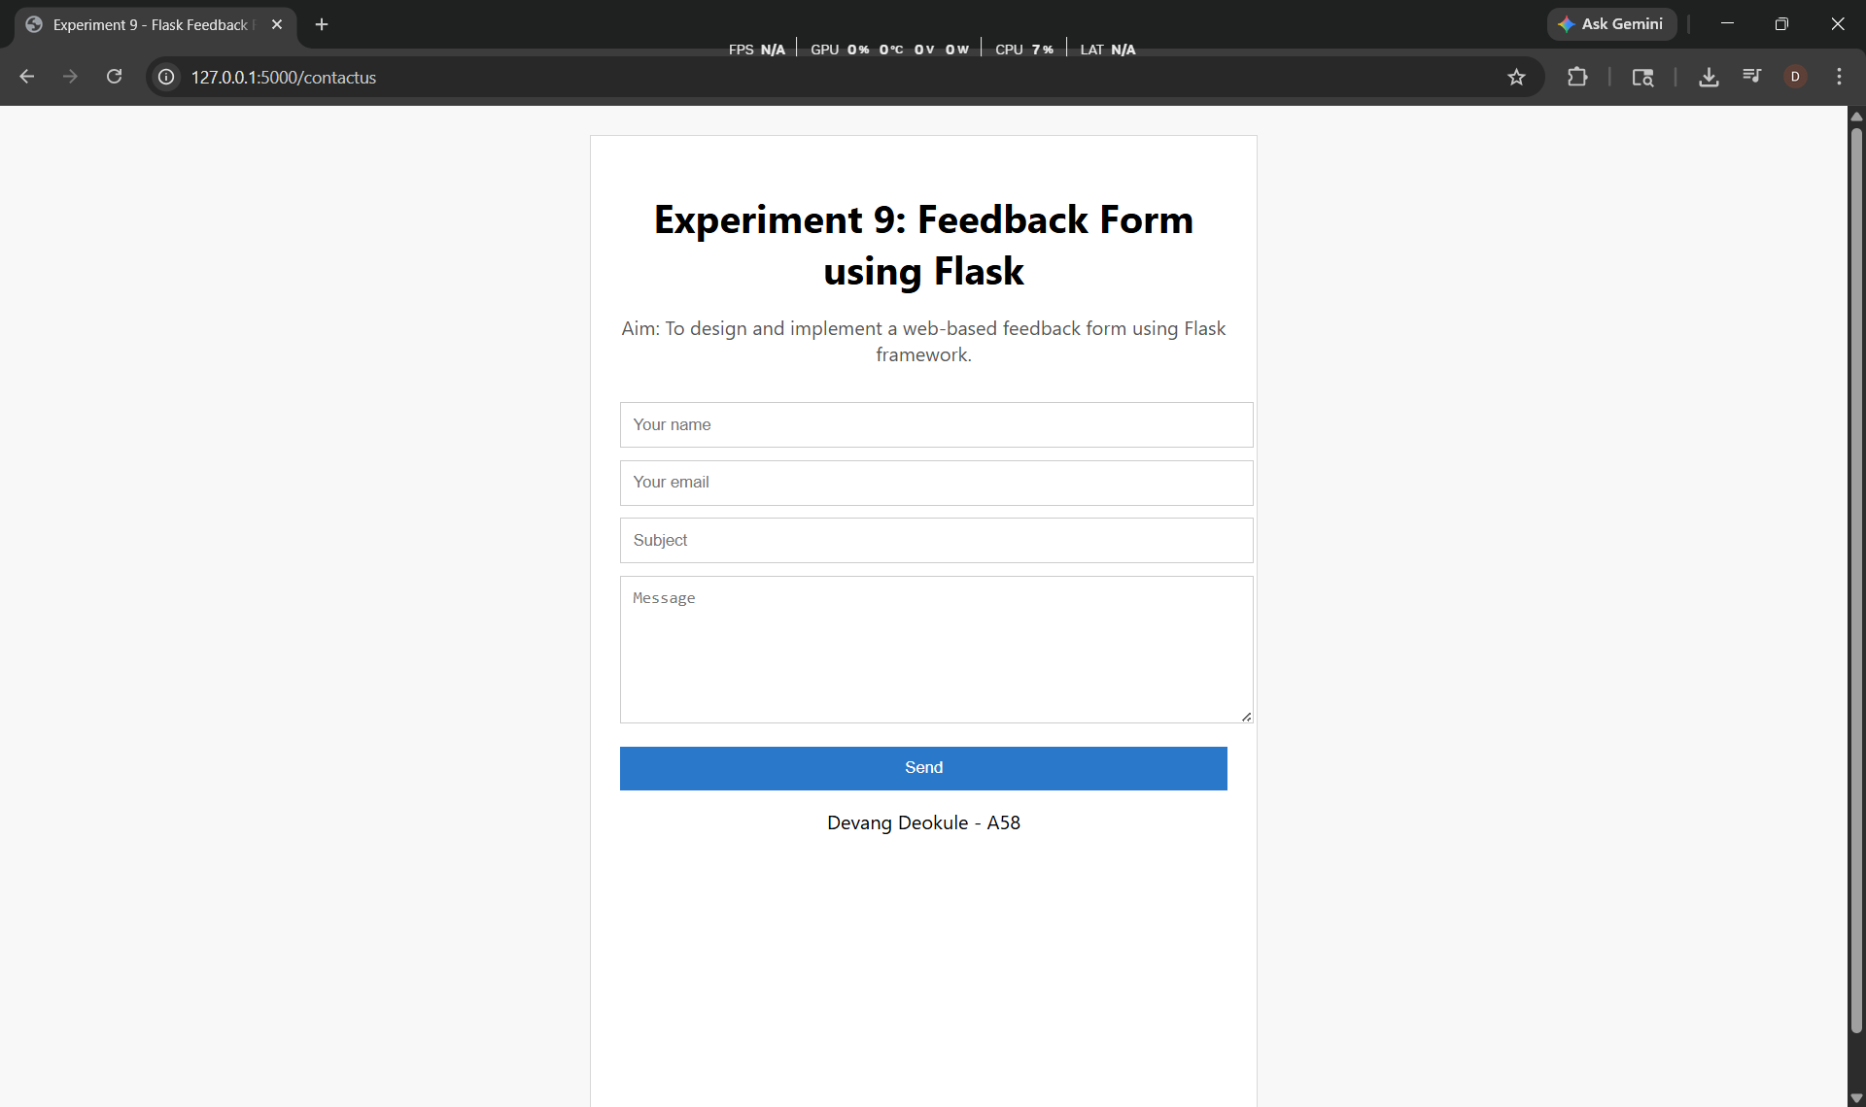
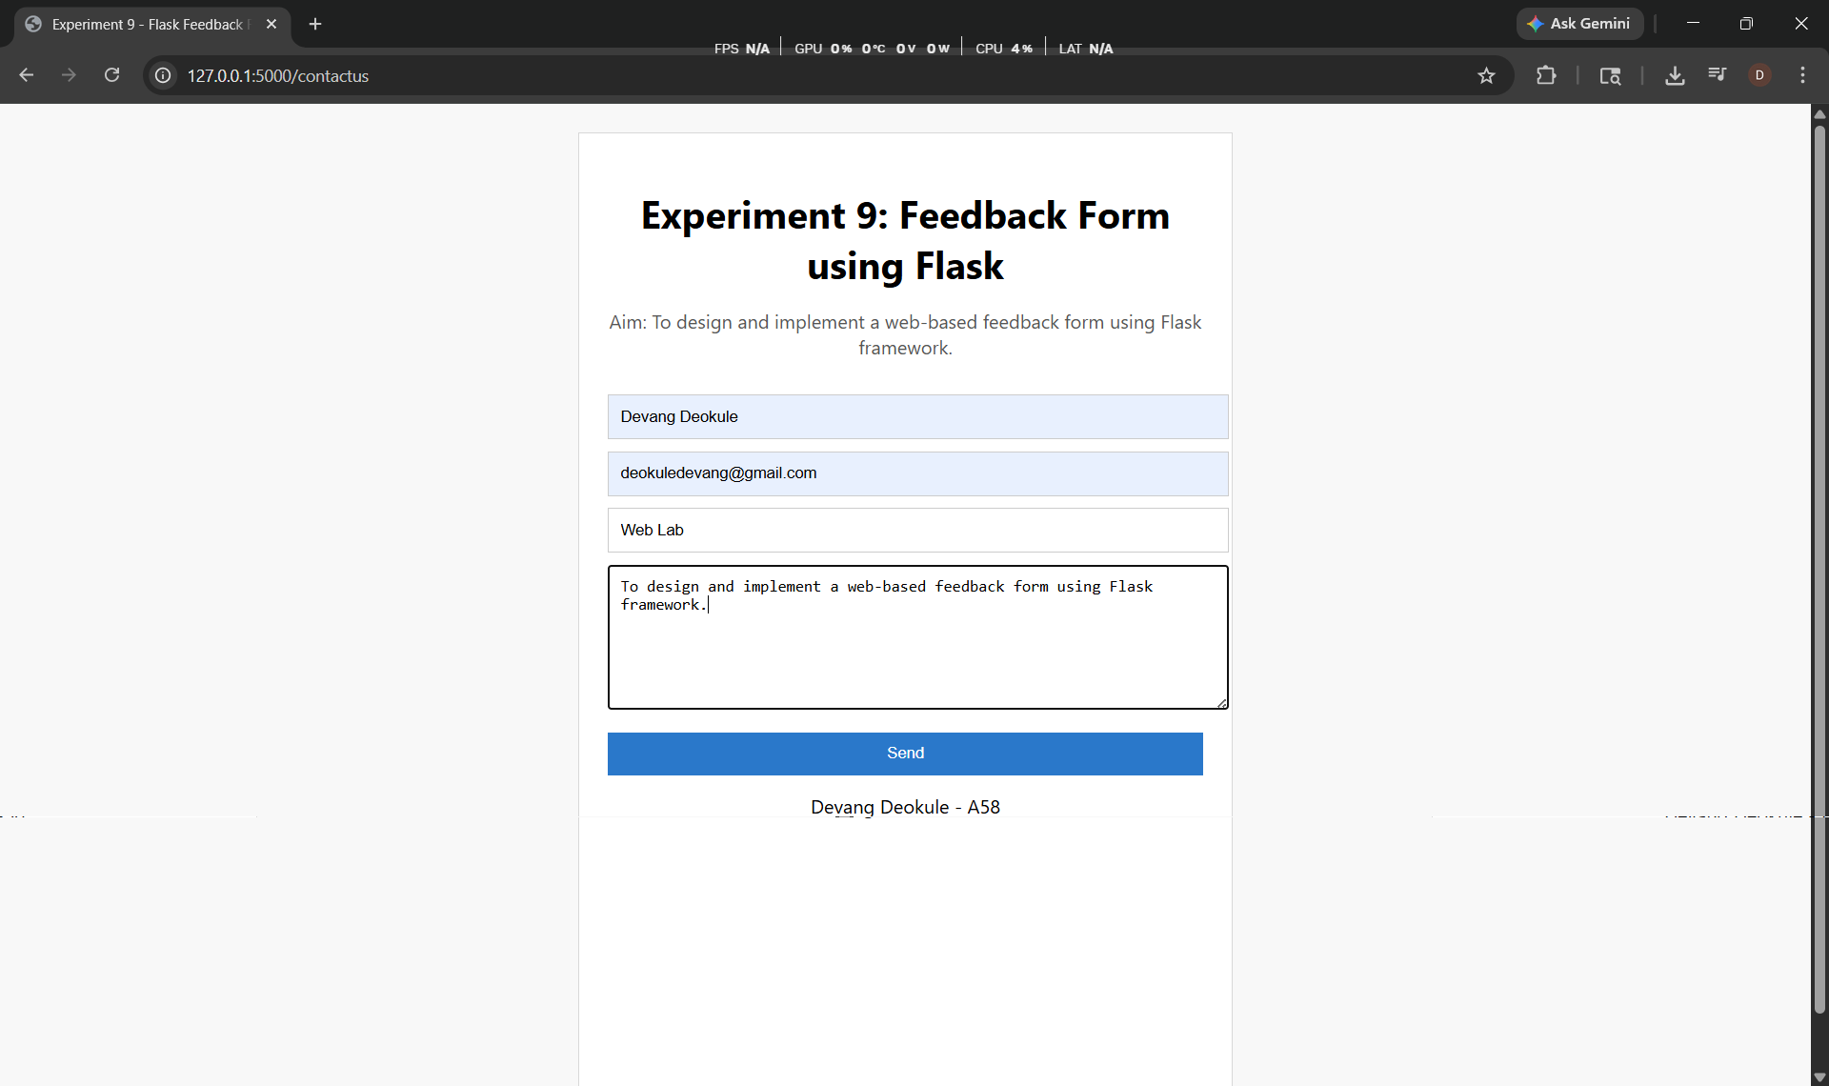
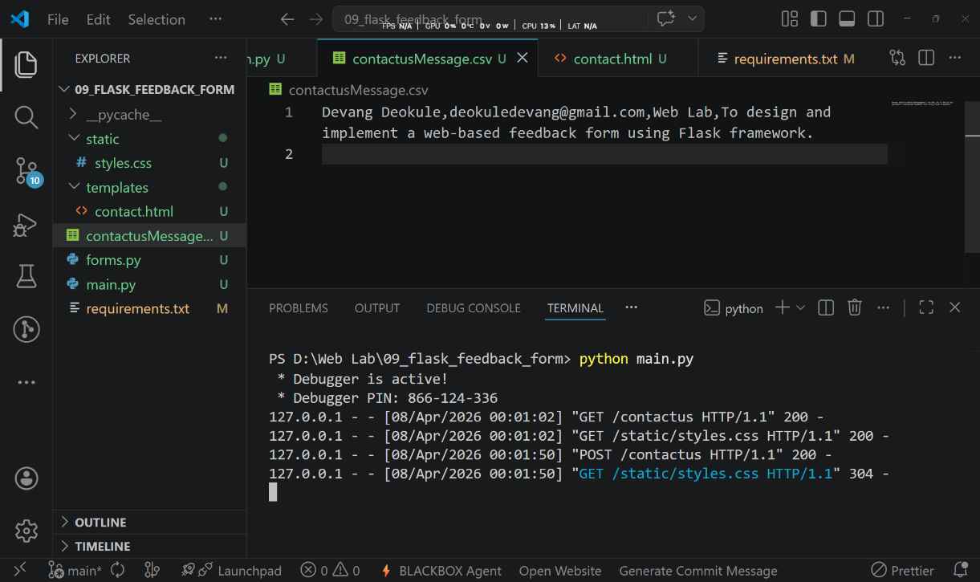

Code:
templates/index.html

<!DOCTYPE html>
<html lang="en">
<head>
<meta charset="UTF-8">
<meta name="viewport" content="width=device-width, initial-scale=1.0">
<title>Devang Deokule | Portfolio</title>
<link rel="preconnect" href="https://fonts.googleapis.com">
<link rel="preconnect" href="https://fonts.gstatic.com" crossorigin>
<link href="https://fonts.googleapis.com/css2?family=Source+Sans+3:wght@400;600;700&family=Space+Grotesk:wght@500;700&display=swap" rel="stylesheet">
<link rel="stylesheet" href="{{ url_for('static', filename='styles.css') }}">
</head>
<body>
<header class="topbar">
<div class="container topbar-inner">
<p class="brand">Devang Deokule</p>
<nav class="nav-links">
<a href="#about">About</a>
<a href="#skills">Skills</a>
<a href="#services">Services</a>
<a href="#projects">Projects</a>
<a href="#contact">Contact</a>
</nav>
</div>
</header>

<main class="container">
<section class="hero section" id="home">
<p class="eyebrow">Hello, I am</p>
<h1>Devang Deokule</h1>
<p class="headline">Full Stack Developer | IT Engineering Student</p>
<p class="hero-summary">
Third-year IT engineering student with a diploma in Computer Engineering.
I build practical products across web, mobile, and AI/ML domains.
</p>
<div class="cta-row">
<a class="btn btn-primary" href="https://devang-deokule.github.io/Portfolio/Devang_Deokule_Resume.pdf" target="_blank" rel="noopener">Download Resume</a>
<a class="btn btn-secondary" href="#contact">Let&apos;s Connect</a>
</div>
<ul class="social-row">
<li><a href="https://www.linkedin.com/in/devang-deokule-188584268/" target="_blank" rel="noopener">LinkedIn</a></li>
<li><a href="https://github.com/Devang-Deokule" target="_blank" rel="noopener">GitHub</a></li>
<li><a href="https://x.com/26Devangg" target="_blank" rel="noopener">Twitter</a></li>
<li><a href="mailto:deokuledevang@gmail.com">Email</a></li>
</ul>
</section>

<section class="panel section" id="about">
<h2>About Me</h2>
<p>
I am a third-year IT engineering student with a diploma in Computer Engineering.
I have worked on multiple projects and gained hands-on experience in software development,
AI/ML, web applications, mobile applications, databases, and software testing.
</p>
<p>
I enjoy exploring new technologies and building solutions for real-world problems.
Whether it is coding, designing, or testing, I like being involved in every stage of development.
I am always looking for opportunities to learn, collaborate, and grow in tech.
</p>
</section>

<section class="panel section" id="skills">
<h2>Skills</h2>
<ul class="skill-list">
<li>Android Development</li>
<li>Java</li>
<li>Kotlin</li>
<li>UI/UX Design</li>
<li>Firebase</li>
<li>RESTful APIs</li>
<li>HTML5 / CSS3</li>
<li>JavaScript</li>
<li>React</li>
<li>C / C++</li>
<li>Python</li>
<li>SQL</li>
</ul>
</section>

<section class="panel section" id="services">
<h2>Services</h2>
<div class="service-grid">
<article class="service-card">
<h3>Website Development</h3>
<p>Custom website development with clean and efficient code for strong performance across devices.</p>
<ul>
<li>Responsive design</li>
<li>Cross-browser compatibility</li>
<li>Performance optimization</li>
</ul>
</article>
<article class="service-card">
<h3>Android App Development</h3>
<p>Native Android applications focused on usability, speed, and maintainable architecture.</p>
<ul>
<li>Custom UI/UX</li>
<li>API integration</li>
<li>Scalable mobile features</li>
</ul>
</article>
<article class="service-card">
<h3>Desktop Application Development</h3>
<p>Desktop software tailored to business and productivity workflows.</p>
<ul>
<li>Cross-platform support</li>
<li>Database integration</li>
<li>Custom business logic</li>
</ul>
</article>
<article class="service-card">
<h3>UI/UX Design</h3>
<p>User-centered interfaces that are clean, clear, and practical for real users.</p>
<ul>
<li>Wireframing and prototyping</li>
<li>User research</li>
<li>Usability-first design</li>
</ul>
</article>
</div>
</section>

<section class="panel section" id="projects">
<h2>Featured Projects</h2>
<div class="project-grid">
<article class="project-card">
<h3>VESP-App</h3>
<p>Android app for college operations with attendance, results, fees, and digital ID using Jetpack Compose and Firebase.</p>
<div class="project-links">
<a href="https://devang-deokule.github.io/Portfolio/VES%20Polytechnic%20The%20Ultimate%20Academic%20Companion%20Application.pdf" target="_blank" rel="noopener">Case Study</a>
<a href="https://github.com/Devang-Deokule/VESP-App.git" target="_blank" rel="noopener">GitHub</a>
</div>
</article>
<article class="project-card">
<h3>Signify</h3>
<p>Real-time sign language detection using MediaPipe, OpenCV, and a custom ML model for text and speech output.</p>
<div class="project-links">
<a href="https://www.linkedin.com/posts/devang-deokule-188584268_hackathon-codestrom2025-socialimpact-activity-7350186339482439680-5dTd" target="_blank" rel="noopener">Demo</a>
<a href="https://github.com/Devang-Deokule/Signify" target="_blank" rel="noopener">GitHub</a>
</div>
</article>
<article class="project-card">
<h3>Weather Application</h3>
<p>Weather app with real-time weather data, forecasts, and location-based updates using public APIs.</p>
<div class="project-links">
<a href="https://github.com/Devang-Deokule/Weather-Application" target="_blank" rel="noopener">GitHub</a>
</div>
</article>
<article class="project-card">
<h3>Shree Pest Control Services</h3>
<p>Business website project focused on presenting services and improving client discovery online.</p>
<div class="project-links">
<a href="https://github.com/Devang-Deokule/ShreePestControlServices.git" target="_blank" rel="noopener">GitHub</a>
</div>
</article>
<article class="project-card">
<h3>NOVA - Personal Voice Assistant</h3>
<p>Voice assistant with chat-based interface for app control, messaging, and live updates through APIs.</p>
<div class="project-links">
<a href="https://github.com/vira250/Full-Voice-Automation" target="_blank" rel="noopener">GitHub</a>
</div>
</article>
<article class="project-card">
<h3>AI Legal Verifier</h3>
<p>AI-based tool to verify legal content against Indian laws using semantic search and embedding workflows.</p>
<div class="project-links">
<a href="https://www.linkedin.com/posts/devang-deokule-188584268_hackathonfinalist-ieee-legaltech-activity-7345326483814416403-QnuF" target="_blank" rel="noopener">Demo</a>
<a href="https://github.com/vira250/AI-Legal-Verifier.git" target="_blank" rel="noopener">GitHub</a>
</div>
</article>
</div>
</section>

<section class="panel section" id="education">
<h2>Education</h2>
<div class="education-card">
<h3>B.E. in Information Technology</h3>
<p>Currently in third year, focused on software engineering, web technologies, and AI/ML projects.</p>
</div>
<div class="education-card">
<h3>Diploma in Computer Engineering</h3>
<p>Built strong foundations in programming, databases, and application development.</p>
</div>
</section>

<section class="panel section" id="contact">
<h2>Contact</h2>
<p>
Feel free to reach out if you are looking for a developer, want to collaborate,
or just want to connect.
</p>
<div class="contact-grid">
<p><strong>Email:</strong> <a href="mailto:deokuledevang@gmail.com">deokuledevang@gmail.com</a></p>
<p><strong>Phone:</strong> <a href="tel:+917039969768">+91 7039969768</a></p>
<p><strong>Location:</strong> Mumbai, India</p>
</div>
<form class="contact-form" action="{{ url_for('sendemail') }}" method="post">
<h3>Send a Message</h3>
<div class="form-grid">
<label>
Your Name
<input type="text" name="name" required>
</label>
<label>
Your Email
<input type="email" name="_replyto" required>
</label>
</div>
<label>
Subject
<input type="text" name="Subject" required>
</label>
<label>
Your Message
<textarea name="message" rows="5" required></textarea>
</label>
<button class="btn btn-primary" type="submit">Send Message</button>
</form>
<ul class="contact-links">
<li><a href="https://www.linkedin.com/in/devang-deokule-188584268/" target="_blank" rel="noopener">LinkedIn</a></li>
<li><a href="https://github.com/Devang-Deokule" target="_blank" rel="noopener">GitHub</a></li>
<li><a href="https://x.com/26Devangg" target="_blank" rel="noopener">Twitter</a></li>
<li><a href="https://www.instagram.com/devangg26?igsh=MTJ2ZmR4cmtycDFoZQ==" target="_blank" rel="noopener">Instagram</a></li>
</ul>
</section>
</main>

<footer class="site-footer">
<p>© 2025 Devang Deokule. All rights reserved.</p>
</footer>
</body>
</html>

static/styles.css

:root {
--bg-top: #f9fbfd;
--bg-bottom: #e9f0f6;
--surface: #ffffff;
--surface-soft: #f3f8fc;
--ink: #13293d;
--muted: #4d6174;
--accent: #0f766e;
--accent-dark: #0b4d49;
--line: #d2dfea;
--shadow: 0 10px 30px rgba(19, 41, 61, 0.08);
}

* {
box-sizing: border-box;
}

html,
body {
margin: 0;
padding: 0;
}

body {
font-family: "Source Sans 3", "Segoe UI", sans-serif;
color: var(--ink);
background: linear-gradient(180deg, var(--bg-top), var(--bg-bottom));
line-height: 1.6;
}

a {
color: var(--accent-dark);
}

.container {
width: min(1120px, 92%);
margin: 0 auto;
}

.topbar {
position: sticky;
top: 0;
z-index: 10;
background: rgba(249, 251, 253, 0.95);
border-bottom: 1px solid var(--line);
}

.topbar-inner {
min-height: 70px;
display: flex;
align-items: center;
justify-content: space-between;
gap: 20px;
}

.brand {
margin: 0;
font-family: "Space Grotesk", sans-serif;
font-size: 1.1rem;
font-weight: 700;
letter-spacing: 0.4px;
}

.nav-links {
display: flex;
flex-wrap: wrap;
gap: 14px;
}

.nav-links a {
text-decoration: none;
color: var(--ink);
font-weight: 600;
padding: 4px 0;
}

.section {
margin-top: 26px;
}

.hero {
margin-top: 32px;
background: var(--surface);
border: 1px solid var(--line);
border-radius: 18px;
box-shadow: var(--shadow);
padding: 48px 34px;
}

.eyebrow {
margin: 0;
font-weight: 700;
color: var(--muted);
text-transform: uppercase;
letter-spacing: 1.4px;
font-size: 0.82rem;
}

.hero h1 {
margin: 8px 0 4px;
font-family: "Space Grotesk", sans-serif;
font-size: clamp(2rem, 5vw, 3.2rem);
line-height: 1.15;
}

.headline {
margin: 0;
font-size: 1.1rem;
font-weight: 700;
color: var(--accent-dark);
}

.hero-summary {
max-width: 760px;
margin: 18px 0 0;
color: var(--muted);
font-size: 1.05rem;
}

.cta-row {
margin-top: 24px;
display: flex;
flex-wrap: wrap;
gap: 12px;
}

.btn {
display: inline-block;
text-decoration: none;
padding: 10px 18px;
border-radius: 10px;
font-weight: 700;
border: 1px solid transparent;
}

.btn-primary {
background: var(--accent);
color: #ffffff;
border-color: var(--accent);
}

.btn-secondary {
background: var(--surface-soft);
color: var(--ink);
border-color: var(--line);
}

.social-row {
list-style: none;
display: flex;
flex-wrap: wrap;
gap: 14px;
margin: 20px 0 0;
padding: 0;
}

.social-row a {
text-decoration: none;
font-weight: 600;
}

.panel {
background: var(--surface);
border: 1px solid var(--line);
border-radius: 16px;
padding: 28px;
box-shadow: var(--shadow);
}

.panel h2 {
margin: 0 0 14px;
font-family: "Space Grotesk", sans-serif;
font-size: 1.7rem;
}

.panel p {
margin: 0 0 12px;
color: var(--muted);
}

.skill-list {
display: grid;
grid-template-columns: repeat(4, minmax(0, 1fr));
gap: 10px;
margin: 0;
padding: 0;
list-style: none;
}

.skill-list li {
background: var(--surface-soft);
border: 1px solid var(--line);
border-radius: 10px;
padding: 10px;
font-weight: 600;
color: var(--ink);
text-align: center;
}

.service-grid {
display: grid;
grid-template-columns: repeat(2, minmax(0, 1fr));
gap: 16px;
}

.service-card,
.project-card,
.education-card {
border: 1px solid var(--line);
border-radius: 12px;
padding: 16px;
background: var(--surface-soft);
}

.service-card h3,
.project-card h3,
.education-card h3 {
margin-top: 0;
margin-bottom: 8px;
font-size: 1.08rem;
}

.service-card p,
.project-card p,
.education-card p {
margin-bottom: 10px;
}

.service-card ul {
margin: 0;
padding-left: 18px;
color: var(--muted);
}

.project-grid {
display: grid;
grid-template-columns: repeat(2, minmax(0, 1fr));
gap: 16px;
}

.project-links {
display: flex;
flex-wrap: wrap;
gap: 10px;
}

.project-links a {
text-decoration: none;
font-weight: 700;
font-size: 0.92rem;
padding: 7px 10px;
border-radius: 8px;
background: #ffffff;
border: 1px solid var(--line);
}

.contact-grid {
display: grid;
grid-template-columns: repeat(3, minmax(0, 1fr));
gap: 10px;
margin: 12px 0 8px;
}

.contact-grid p {
margin: 0;
background: var(--surface-soft);
border: 1px solid var(--line);
border-radius: 10px;
padding: 10px;
}

.contact-links {
list-style: none;
display: flex;
flex-wrap: wrap;
gap: 14px;
margin: 14px 0 0;
padding: 0;
}

.contact-links a {
text-decoration: none;
font-weight: 700;
}

.contact-form {
margin-top: 14px;
background: var(--surface-soft);
border: 1px solid var(--line);
border-radius: 12px;
padding: 14px;
}

.contact-form h3 {
margin: 0 0 10px;
font-size: 1.1rem;
}

.contact-form label {
display: block;
margin-bottom: 10px;
font-weight: 600;
color: var(--ink);
}

.form-grid {
display: grid;
grid-template-columns: repeat(2, minmax(0, 1fr));
gap: 10px;
}

.contact-form input,
.contact-form textarea {
width: 100%;
margin-top: 6px;
padding: 10px;
border: 1px solid var(--line);
border-radius: 8px;
font: inherit;
color: var(--ink);
background: #ffffff;
}

.contact-form textarea {
resize: vertical;
}

.site-footer {
margin-top: 28px;
border-top: 1px solid var(--line);
text-align: center;
padding: 18px 0 24px;
color: var(--muted);
}

@media (max-width: 980px) {
.skill-list {
grid-template-columns: repeat(3, minmax(0, 1fr));
}

.project-grid,
.service-grid,
.contact-grid {
grid-template-columns: repeat(2, minmax(0, 1fr));
}
}

@media (max-width: 700px) {
.topbar-inner {
flex-direction: column;
align-items: flex-start;
justify-content: center;
padding: 12px 0;
}

.hero {
padding: 30px 20px;
}

.panel {
padding: 20px;
}

.skill-list,
.project-grid,
.service-grid,
.contact-grid {
grid-template-columns: 1fr;
}

.form-grid {
grid-template-columns: 1fr;
}
}

main.py
import os
import smtplib
from email.message import EmailMessage

from flask import Flask, redirect, render_template, request, url_for

app = Flask(__name__)

@app.route("/")
def index():
return render_template("index.html")

@app.route("/sendemail/", methods=["POST"])
def sendemail():
if request.method == "POST":
name = request.form.get("name", "").strip()
subject = request.form.get("Subject", "").strip()
email = request.form.get("_replyto", "").strip()
message = request.form.get("message", "").strip()

smtp_host = os.getenv("SMTP_HOST", "smtp.gmail.com")
smtp_port = int(os.getenv("SMTP_PORT", "587"))
smtp_user = os.getenv("SMTP_USER")
smtp_password = os.getenv("SMTP_PASSWORD")
receiver_email = os.getenv("RECEIVER_EMAIL", "deokuledevang@gmail.com")

if smtp_user and smtp_password:
msg = EmailMessage()
msg.set_content(
f"First Name : {name}\n"
f"Email : {email}\n"
f"Subject : {subject}\n"
f"Message : {message}"
)
msg["Subject"] = "New Response on Personal Website"
msg["From"] = smtp_user
msg["To"] = receiver_email

try:
with smtplib.SMTP(smtp_host, smtp_port, timeout=20) as server:
server.ehlo()
server.starttls()
server.login(smtp_user, smtp_password)
server.send_message(msg)
except Exception:
pass

return redirect(url_for("index"))

if __name__ == "__main__":
app.run(debug=True)

requirements.txt
Flask==3.0.3

Output:
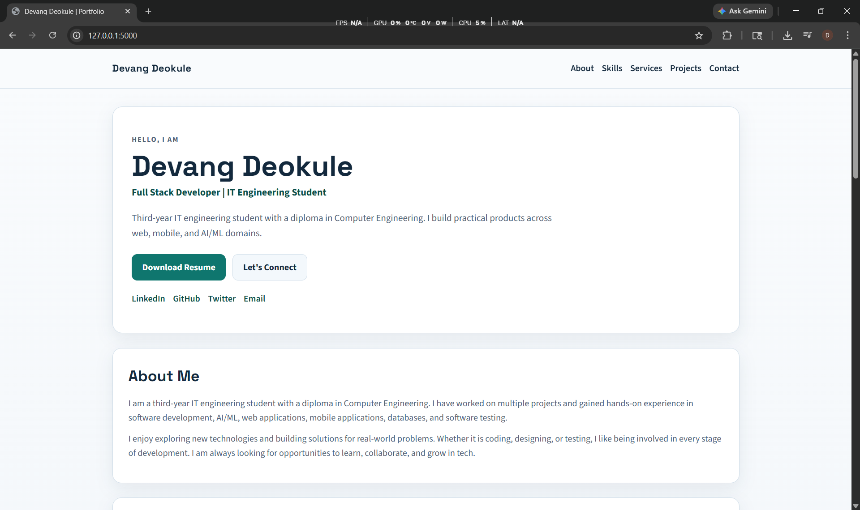
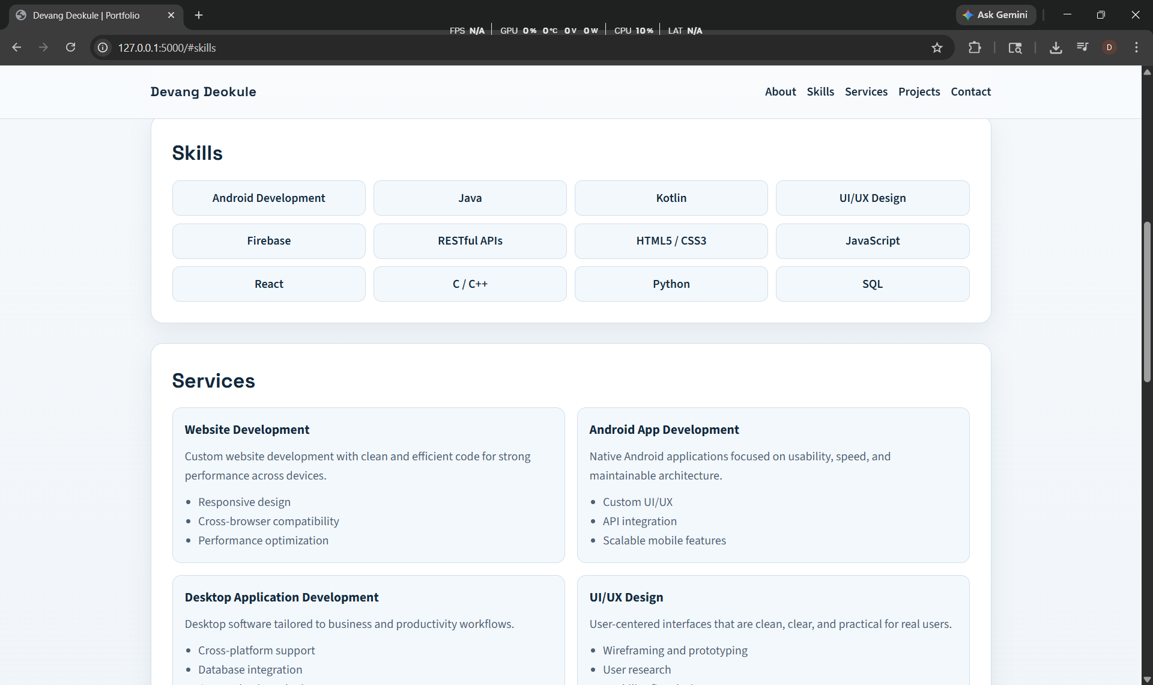
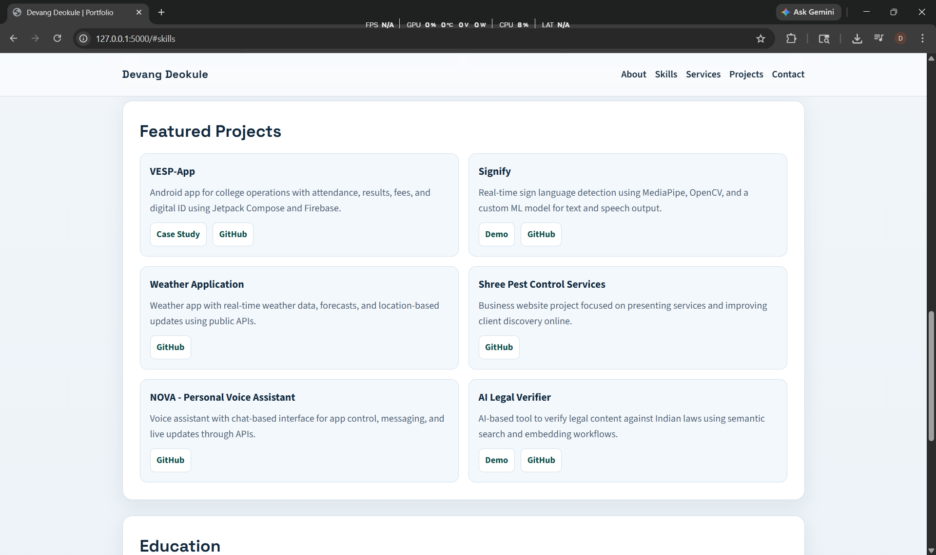
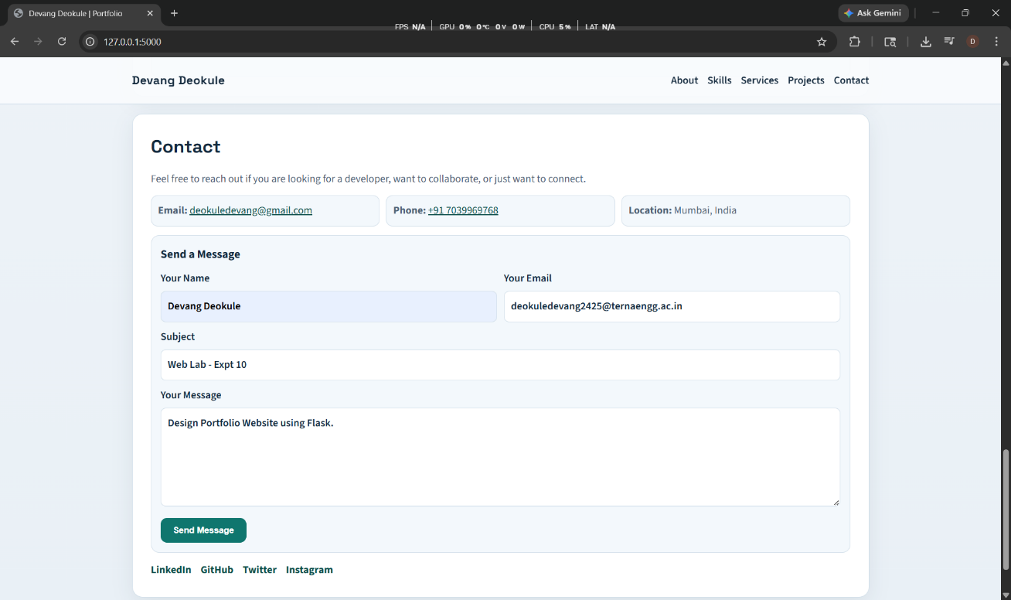
Code:
models/User.js
const mongoose = require("mongoose");
const userSchema = new mongoose.Schema(
{
name: {
type: String,
required: true,
trim: true,
},
age: {
type: Number,
required: true,
min: 0,
},
},
{
timestamps: true,
}
);
module.exports = mongoose.model("User", userSchema);

server.js

const express = require("express");
const mongoose = require("mongoose");
const User = require("./models/User");
require("dotenv").config({ override: true });

const app = express();
app.use(express.json());

const MONGO_URI = process.env.MONGO_URI;
const PORT = process.env.PORT || 5000;

if (!MONGO_URI) {
console.error("MONGO_URI is missing. Add it in .env file.");
process.exit(1);
}

mongoose
.connect(MONGO_URI)
.then(() => console.log("MongoDB Connected"))
.catch((err) => console.log(err));

// CREATE
app.post("/users", async (req, res) => {
try {
const user = new User(req.body);
const savedUser = await user.save();
res.status(201).json(savedUser);
} catch (err) {
res.status(400).json({ error: err.message });
}
});

// READ ALL
app.get("/users", async (req, res) => {
try {
const users = await User.find();
res.json(users);
} catch (err) {
res.status(500).json({ error: err.message });
}
});

// READ SINGLE
app.get("/users/:id", async (req, res) => {
try {
const user = await User.findById(req.params.id);
if (!user) {
return res.status(404).json({ msg: "User not found" });
}
res.json(user);
} catch (err) {
res.status(500).json({ error: err.message });
}
});

// UPDATE
app.put("/users/:id", async (req, res) => {
try {
const updatedUser = await User.findByIdAndUpdate(req.params.id, req.body, {
new: true,
runValidators: true,
});

if (!updatedUser) {
return res.status(404).json({ msg: "User not found" });
}

res.json(updatedUser);
} catch (err) {
res.status(400).json({ error: err.message });
}
});

// DELETE
app.delete("/users/:id", async (req, res) => {
try {
const deletedUser = await User.findByIdAndDelete(req.params.id);

if (!deletedUser) {
return res.status(404).json({ msg: "User not found" });
}

res.json({ msg: "User deleted" });
} catch (err) {
res.status(500).json({ error: err.message });
}
});

app.get("/", (req, res) => {
res.json({
message: "RESTful API is running",
endpoints: ["POST /users", "GET /users", "GET /users/:id", "PUT /users/:id", "DELETE /users/:id"],
});
});

// Start Server
app.listen(PORT, () => {
console.log(`Server running on port ${PORT}`);
});

Output:
GET
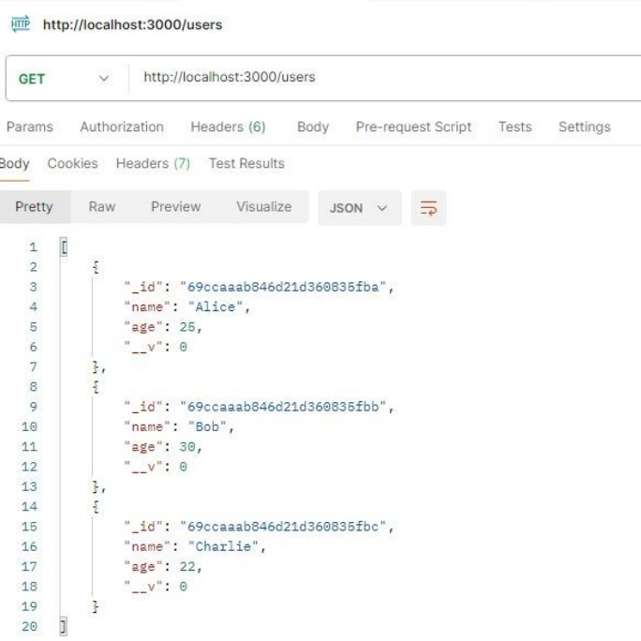

POST

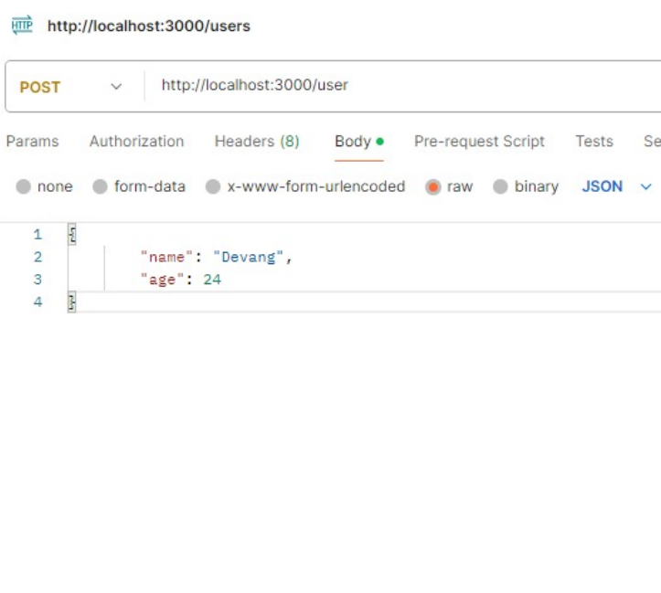

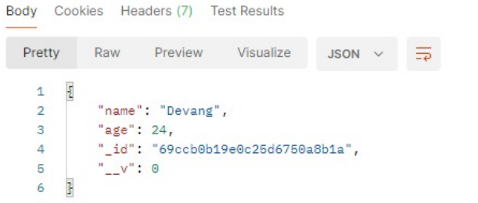
PUT
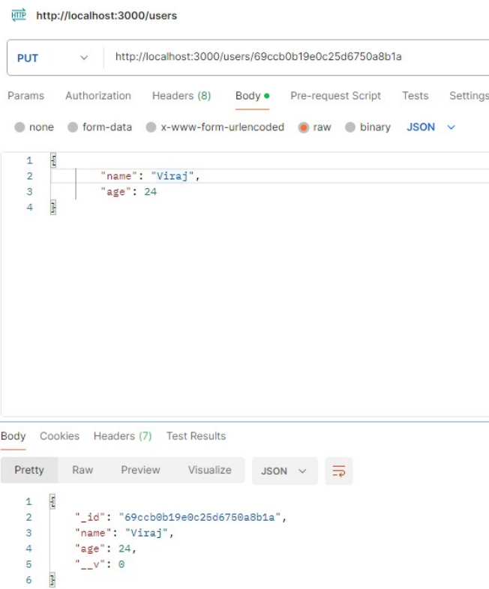

DELETE
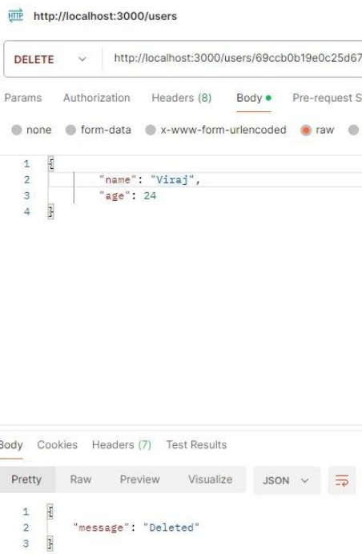

MongoDB
